 skene medical group 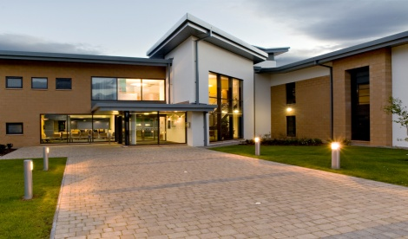

**Telephonist/Receptionist** **– 37 hours per week**

**Salary:** £22,653 to £27,639 scale dependant on experience

**Hours of work: Monday – 12.30 – 17.30, Tuesday, Wednesday and Thursday – 08.00 – 17.30, Friday - 08.00 – 13.00 (Hours non-negotiable, please only apply if you can commit to these hours)**

An opportunity has become available to join our team. We invite applications from forward thinking, flexible and hardworking, multi-tasking individual to complement our existing team. You must be reliable with excellent communication, interpersonal and team skills and have an ability to work under pressure. Experience of working in General Practice would be advantageous but not essential as full training will be given.

Skene is a supportive, friendly and well managed practice with over 15,000 patients looking for a dynamic and enthusiastic telephonist/receptionist to join our multi disciplinary team who are committed to delivering excellent patient care.

Practice information can be found at [www.skenemedicalgroup.co.uk](http://www.skenemedicalgroup.co.uk)

For an application form and job description please contact:

Claire Mckay or Karin Mackay

Office co-ordinator

Skene Medical Group

Discovery Drive

Arnhall Business Park

Westhill

Aberdeenshire

AB32 6FG

e-mail: [gram.skeneadministrator@nhs.scot](mailto:gram.skeneadministrator@nhs.scot)

Closing date: Monday 29th September 2025.

Interviews will be on: Friday 3rd October 2025.